**Conference with Lydia and Claude Bourguignon “Quels sols pour demain?”**

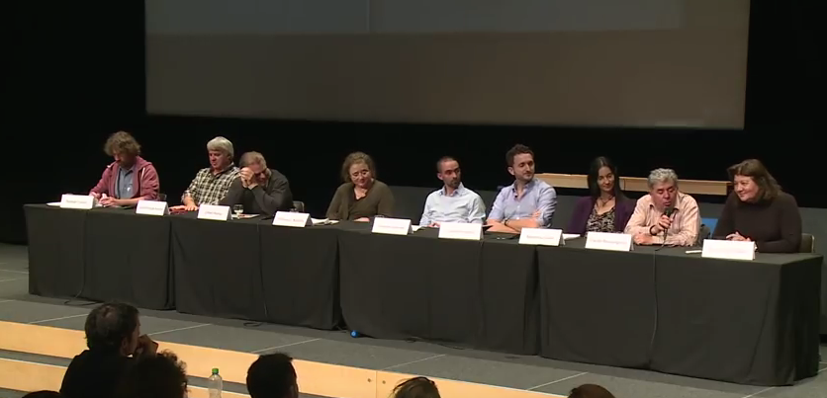

We, the team project on the app for measuring the soils had the chance to attend a conference given mainly by Claude and Lydia Bourguignon at the University of Lausanne, the Tuesday 7th of November from 5:30 to 7:30 pm.

The title of the conference was “Which soils for tomorrow?” and nine speakers were invited:

*Lydia and Claude Bourguignon*: very famous specialist of the soils, researchers and agronomists,

*Dominique Barjolle*: chef of the division of direct payments and agro-ecology in the service of agriculture and viticulture in the Vaud county,

*Jordan Vacheron*: 1st assistant at the faculty of biology and medical school (UNIL)

*Stéphanie Grand*: master assistant at the faculty of geo-science and environment (UNIL)

*Jean-Philippe Barilier*: farmer and wine grower

*Raphaël Charles*: chef of the FIBL (antenne romande) and from the institute of research in biological agriculture,

*François Füllemann*, cantonal paedologist in Vaud.

*Gilbert Ramuz*, farmer

*Christophe Pidoux* (moderator): director of Agrilogie Grande-Verney in Marcelin.

The conference began with a great presentation made by Claude and Lydia Bourguignon on the problems of the agriculture, the erosion, the pollution, the extinction of the humus, the biodiversity in the soils and the clay. They’ve presented few case study and also soils on which they’ve worked with the owners and farmers to give back the biodiversity and fertility of those soils. They’ve presented various technics of land’s regeneration proposed on the bases of knowledge in paedology, biology and other methods in agroecology and organic agriculture.

The discussion that followed with the guest was rewarding. It was interesting to hear the testimony of different actors: from the researcher in the laboratory or the university, the political actors, the association, to the organic and conventional actors.

In this conference it was great to hear about the health status of the soils in Swiss and in the Vaud County. They’re not going very well but not as bad as other European country such as France. Because of the small size of Switzerland, there have been fewer investments on an industrial agriculture that has completely destroyed the soils of our neighbours. It was also reassuring to hear from the FIBL, the Research Institute of Organic Agriculture: they’re working a lot in Switzerland and in its French part to promote and develop an ecological agriculture. Even the two farmers present, one doing organic agriculture, the other conventional, were agreeing on the fact that they should both improve their technics by stopping ploughing the soils and they were interested in discussing with the Bourguignon. As the two celebrity admitted, changing the habits in agriculture is very hard and respectful technics for the groundwork are really difficult to put in place.

There was not enough time after the conference for a real time of debate or questions but we had the chance to approach Claude Bourguignon and talk a little bit of our project. He encouraged us to continue on this way and was really nice.

After that, we met two students doing a master at the University of Lausanne in biology and they were specialization themselves with their master project on the soils and its indicators of biodiversity. We had a great discussion and we’ve expanded our contact list of inspiring people to contact for a partnership on our project.

Anne-Pia Marty, Marcelo Veloso, Loukas Garnis, Océane Schaub